# Practical No.1

**Aim:** Write an Android program to demonstrate Android lifecycle.

# Objective:

To understand Android Activity lifecycle.

# Code:

## MainActivity.java:-

package com.riya.activitylifecyclepract1; import androidx.appcompat.app.AppCompatActivity; import android.util.Log;

import android.os.Bundle;

public class MainActivity extends AppCompatActivity {

@Override

protected void onCreate(Bundle savedInstanceState) {

super.onCreate(savedInstanceState); setContentView(R.layout.*activity_main*); Log.*d*("lifecycle","onCreate invoked");

## activity_main.xml:-

*<?*xml version="1.0" encoding="utf-8"*?>*

<RelativeLayout xmlns:android="<http://schemas.android.com/apk/re> s/android"

xmlns:tools="<http://schemas.android.com/tools>" android:layout_width="match_parent" android:layout_height="match_parent" tools:context=".MainActivity">

<TextView android:layout_width="wrap_content" android:layout_height="wrap_content" android:text="Activity Lifecycle" />

</RelativeLayout>

# Output:

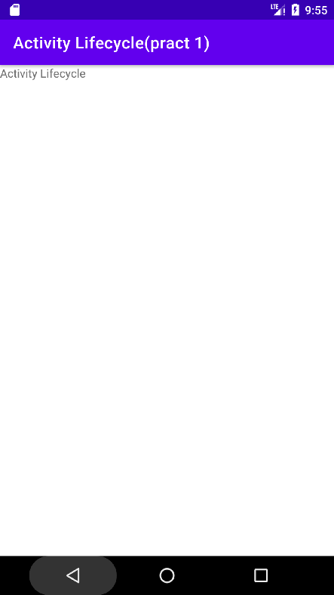}

@Override

protected void onStart() { super.onStart(); Log.*d*("lifecycle","onStart invoked");

}

@Override

protected void onResume() { super.onResume(); Log.*d*("lifecycle","onResume invoked");

}

@Override

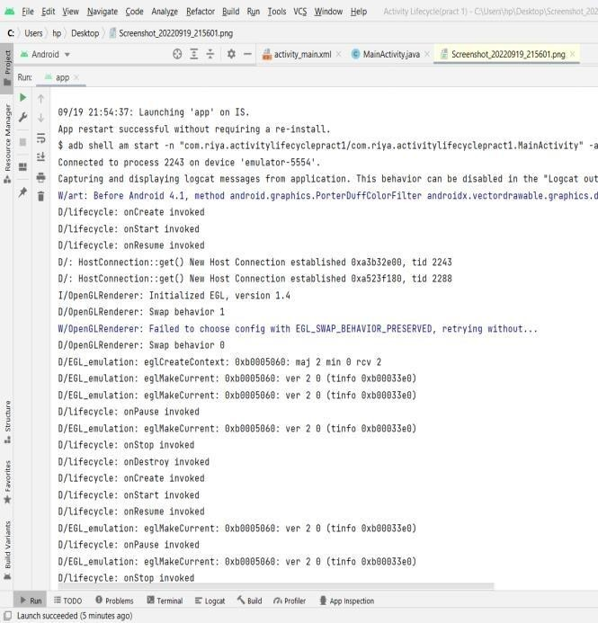protected void onPause() { super.onPause(); Log.*d*("lifecycle","onPause invoked");

}

@Override

protected void onStop() { super.onStop(); Log.*d*("lifecycle","onStop invoked");

}

@Override

protected void onRestart() { super.onRestart(); Log.*d*("lifecycle","onRestart invoked");

}

@Override

protected void onDestroy() { super.onDestroy(); Log.*d*("lifecycle","onDestroy invoked");

}

}

# Practical No.2

**Aim:** Write an Android program to demonstrate Working with checkbox

# Objective:

To understand working of checkbox.

# Code:

## MainActivity.java:-

package com.riya.cafe; import

androidx.appcompat.app.AppCompatActivity;

import android.os.Bundle; import android.view.Menu; import android.view.View; import android.widget.Button;

import android.widget.CheckBox; import android.widget.Toast;

import android.view.View.OnClickListener;

public class MainActivity extends AppCompatActivity {

CheckBox Pizza,Coffee,Burger; Button Button1;

@Override

protected void onCreate(Bundle savedInstanceState) {

super.onCreate(savedInstanceState); setContentView(R.layout.activity_main); addListenerOnButtonClick();

}

public void addListenerOnButtonClick() { Pizza = (CheckBox)

findViewById(R.id.checkBox);

Coffee = (CheckBox) findViewById(R.id.checkBox2);

Burger = (CheckBox) findViewById(R.id.checkBox3);

Button1 = (Button) findViewById(R.id.button);

Button1.setOnClickListener(new OnClickListener() {

@Override

public void onClick(View view) {

int totalamount = 0; StringBuilder result = new

StringBuilder();

result.append("Selected Items: "); if (Pizza.isChecked()) {

result.append("\nPizza 10$"); totalamount += 10;

}

if (Coffee.isChecked()) { result.append("\nCoffee 3$"); totalamount += 3;

}

if (Burger.isChecked()) { result.append("\nBurger 6$"); totalamount += 6;

}

result.append("\nTotal amount: " + totalamount + "$");

Toast.makeText(getApplicationContext(), result.toString(), Toast.LENGTH_LONG).show();

}

});

}

}

## activity_main.xml:-

<?xml version="1.0" encoding="utf-8"?>

<RelativeLayout xmlns:android="<http://schemas.android.com/apk/re> s/android"

xmlns:app="<http://schemas.android.com/apk/res-> auto"

xmlns:tools="<http://schemas.android.com/tools>" android:layout_width="match_parent" android:layout_height="match_parent" tools:context=".MainActivity">

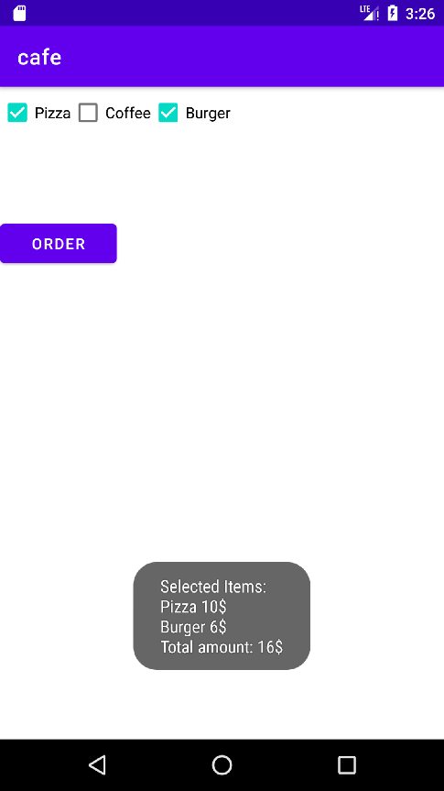<CheckBox android:id="@+id/checkBox" android:layout_width="wrap_content" android:layout_height="wrap_content" android:text="Pizza" />

<CheckBox android:id="@+id/checkBox2" android:layout_width="wrap_content" android:layout_height="wrap_content"

android:layout_toRightOf="@id/checkBox" android:text="Coffee" />

<CheckBox android:id="@+id/checkBox3" android:layout_width="wrap_content" android:layout_height="wrap_content"

android:layout_toRightOf="@id/checkBox2" android:text="Burger" />

<Button

android:id="@+id/button" android:layout_width="108dp" android:layout_height="wrap_content" android:layout_below="@id/checkBox3" android:layout_marginTop="73dp" android:text="Order" />

</RelativeLayout>

# Output:

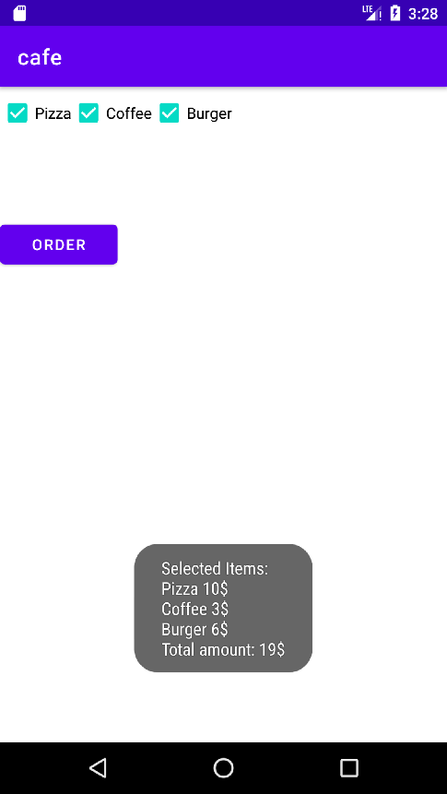

**Practical No.3**

**Aim:** Write an Android program to demonstrate Working with radio group and radio buttons. On click of Radio button Background color should get change and also Temprature get converted into appropriate format.

# Objective:

To understand working of radio button.

# Code:

## MainActivity.java:-

package com.riya.radiogroup_button;

import androidx.appcompat.app.AppCompatActivity;

import android.graphics.Color; import android.os.Bundle; import android.view.View; import android.widget.EditText;

import android.widget.LinearLayout; import android.widget.RadioButton; import android.widget.TextView;

public class MainActivity extends AppCompatActivity {

@Override

protected void onCreate(Bundle savedInstanceState) {

super.onCreate(savedInstanceState); setContentView(R.layout.activity_main);}

public void add(View tv){

LinearLayout l1=(LinearLayout) findViewById(R.id.l1);

TextView result=(TextView) findViewById(R.id.tv2);

EditText et1=(EditText) findViewById(R.id.et1);

double a=Double.parseDouble(String.valueOf(et1.getText(

)));

RadioButton cb=(RadioButton) findViewById(R.id.rd);

RadioButton fb=(RadioButton) findViewById(R.id.rd1);

if(cb.isChecked()) { l1.setBackgroundColor(Color.GREEN); result.setText(f2c(a)+" degree Celsius");

}

else {

l1.setBackgroundColor(Color.RED); result.setText(f2c(a) + " degree

Fahrenheit");}}

private double c2f(double c){ return (c*9)/5+32; }

private double f2c(double f){ return (f-32)*5/9;}}

## activity_main.xml:-

*<?*xml version="1.0" encoding="utf-8"*?>*

<LinearLayout xmlns:android="<http://schemas.android.com/a> pk/res/android" xmlns:app="<http://schemas.android.com/apk/r> es-auto" xmlns:tools="<http://schemas.android.com/tool> s"

android:layout_width="match_parent" android:layout_height="match_parent" android:orientation="vertical" android:id="@+id/l1" tools:context=".MainActivity">

<LinearLayout android:id="@+id/l2"

android:layout_width="wrap_content" android:layout_height="wrap_content" android:orientation="horizontal">

<TextView android:id="@+id/tv" android:layout_width="99dp" android:layout_height="39dp" android:text="Enter value"

tools:layout_editor_absoluteX="37dp" tools:layout_editor_absoluteY="224dp"

/>

<EditText android:id="@+id/et1"

android:layout_width="wrap_content" android:layout_height="wrap_content" android:ems="10" android:inputType="textPersonName" android:text="" tools:layout_editor_absoluteX="158dp" tools:layout_editor_absoluteY="219dp"

# Output:

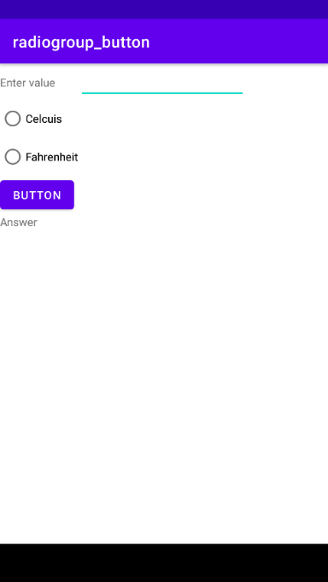/>

</LinearLayout>

<RadioGroup android:layout_width="wrap_content" android:layout_height="wrap_content" tools:layout_editor_absoluteX="71dp" tools:layout_editor_absoluteY="316dp">

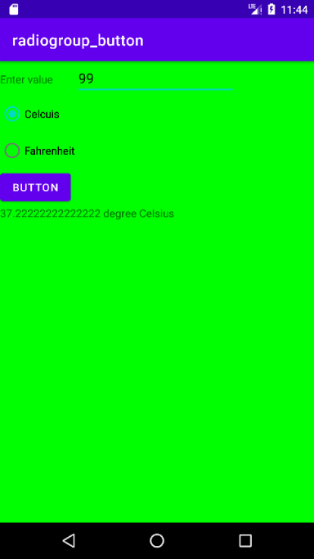<RadioButton android:id="@+id/rd"

android:layout_width="match_parent" android:layout_height="wrap_content" android:text="Celcuis" />

<RadioButton android:id="@+id/rd1" android:layout_width="114dp"

android:layout_height="wrap_content" android:text="Fahrenheit" />

<Button

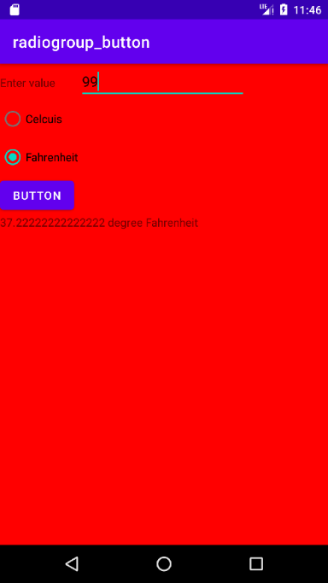android:id="@+id/btn" android:layout_width="wrap_content" android:layout_height="wrap_content" android:text="Button" android:onClick="add" tools:layout_editor_absoluteX="158dp" tools:layout_editor_absoluteY="457dp"

/>

</RadioGroup>

<TextView android:id="@+id/tv2"

android:layout_width="wrap_content" android:layout_height="wrap_content" android:text="Answer" tools:layout_editor_absoluteX="82dp" tools:layout_editor_absoluteY="519dp"

/>

</LinearLayout>

# Practical No.4

**Aim:** Write an Android program to demonstrate Date and time picker.

# Objective:

To understand working of Date and time picker.

# Code:

**Date Picker:-**

## MainActivity.java:-

package com.riya.datepicker; import

androidx.appcompat.app.AppCompatActivity;

import android.os.Bundle; import android.view.View; import android.widget.Button;

import android.widget.DatePicker; import android.widget.Toast;

public class MainActivity extends AppCompatActivity {

DatePicker simpleDatePicker; Button submit;

@Override

protected void onCreate(Bundle savedInstanceState) {

super.onCreate(savedInstanceState); setContentView(R.layout.activity_main);

simpleDatePicker = (DatePicker) findViewById(R.id.simpleDatePicker);

submit = (Button) findViewById(R.id.submitButton);

submit.setOnClickListener(new View.OnClickListener() {

@Override

public void onClick(View v) { String day = "Day = " +

simpleDatePicker.getDayOfMonth();

String month = "Month = " + (simpleDatePicker.getMonth() + 1);

String year = "Year = " + simpleDatePicker.getYear();

Toast.makeText(getApplicationContext(), day + "\n" + month + "\n" + year,

Toast.LENGTH_LONG).show();

}

});

}

}

## activity_main.xml:-

<?xml version="1.0" encoding="utf-8"?>

<RelativeLayout xmlns:android="<http://schemas.android.com/apk/re> s/android"

xmlns:app="<http://schemas.android.com/apk/res-> auto"

xmlns:tools="<http://schemas.android.com/tools>" android:layout_width="match_parent" android:layout_height="match_parent" tools:context=".MainActivity">

<DatePicker android:id="@+id/simpleDatePicker" android:layout_width="wrap_content" android:layout_height="wrap_content" android:background="#AEDF68" android:datePickerMode="spinner" />

<Button

android:id="@+id/submitButton" android:layout_width="200dp" android:layout_height="wrap_content"

android:layout_below="@+id/simpleDatePicker"

android:layout_centerHorizontal="true" android:layout_marginTop="50dp" android:background="#138195" android:text="SUBMIT" android:textColor="#fff"

android:textSize="20sp" android:textStyle="bold" />

</RelativeLayout>

# Time Picker:-

## MainActivity.java:-

package com.riya.timepicker; import

androidx.appcompat.app.AppCompatActivity; import android.os.Bundle;

import android.widget.TextView; import android.widget.TimePicker; import android.widget.Toast;

public class MainActivity extends AppCompatActivity {

TextView time;

TimePicker simpleTimePicker; @Override

protected void onCreate(Bundle savedInstanceState) {

super.onCreate(savedInstanceState); setContentView(R.layout.activity_main); time = (TextView) findViewById(R.id.time);

simpleTimePicker = (TimePicker) findViewById(R.id.simpleTimePicker);

simpleTimePicker.setIs24HourView(false);

simpleTimePicker.setOnTimeChangedListener(ne w

TimePicker.OnTimeChangedListener() { @Override

public void onTimeChanged(TimePicker view, int hourOfDay, int minute) { Toast.makeText(getApplicationContext(), hourOfDay + " " + minute,

Toast.LENGTH_SHORT).show();

time.setText("Time is

:: " + hourOfDay + " : " + minute);

}

});

}

}

## activity_main.xml:-

<?xml version="1.0" encoding="utf-8"?>

<RelativeLayout xmlns:android="<http://schemas.android.com/apk/re> s/android"

xmlns:app="<http://schemas.android.com/apk/res-> auto"

xmlns:tools="<http://schemas.android.com/tools>" android:layout_width="match_parent" android:layout_height="match_parent" tools:context=".MainActivity">

<TimePicker android:id="@+id/simpleTimePicker" android:layout_width="wrap_content" android:layout_height="wrap_content" android:layout_centerHorizontal="true" android:layout_marginTop="50dp" android:background="#090" android:padding="20dp" android:timePickerMode="spinner" />

<TextView android:id="@+id/time"

android:layout_width="wrap_content" android:layout_height="wrap_content" android:layout_centerHorizontal="true" android:text="Time Is ::" android:textColor="#090" android:textSize="20sp" android:textStyle="bold" />

</RelativeLayout>

# Output:

## Date Picker:-

**Time Picker:-**

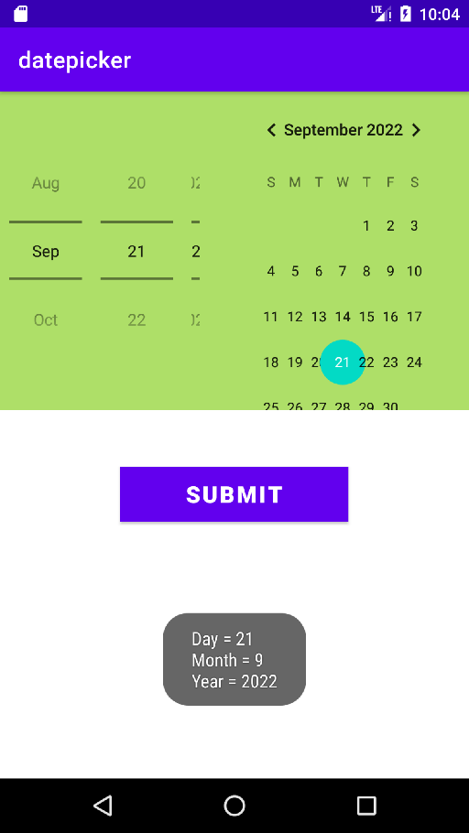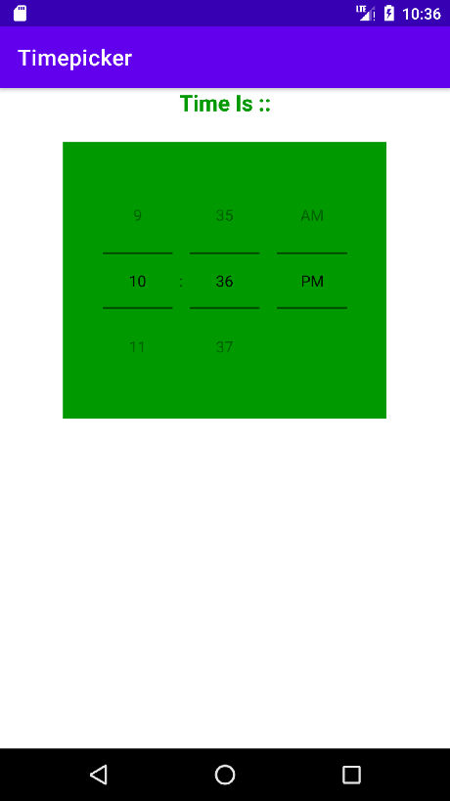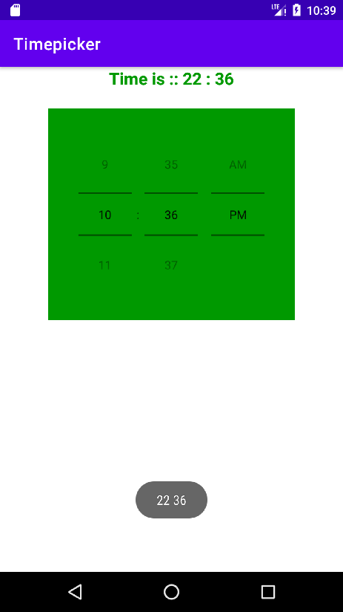

# Practical No.5

**Aim:** Write an Android program Using UI components to create feedback form.

# Objective:

To understand working of feedback form.

# Code:

## MainActivity.java:-

package com.riya.feedbackform; import

androidx.appcompat.app.AppCompatActivity; import android.os.Bundle;

public class MainActivity extends AppCompatActivity {

@Override

protected void onCreate(Bundle savedInstanceState) {

super.onCreate(savedInstanceState); setContentView(R.layout.activity_main);}}

## activity_main.xml:-

<?xml version="1.0" encoding="utf-8"?>

<RelativeLayout xmlns:android="<http://schemas.android.com/apk/re> s/android" xmlns:app="<http://schemas.android.com/apk/res-> auto"

xmlns:tools="<http://schemas.android.com/tools>" android:layout_width="match_parent" android:layout_height="match_parent" tools:context=".MainActivity">

<TableLayout android:layout_width="match_parent" android:layout_height="match_parent">

<TableRow android:layout_width="match_parent" android:layout_height="match_parent">

<TextView android:id="@+id/textView" android:layout_width="wrap_content"

android:layout_height="wrap_content" android:fontFamily="sans-serif-black" android:text="Name" android:textAllCaps="false" android:textColor="#42271F" android:textSize="16sp" android:textStyle="bold" />

<EditText android:id="@+id/editText"

android:layout_width="wrap_content" android:layout_height="wrap_content" android:ems="10" android:inputType="textPersonName" />

</TableRow>

<TableRow

android:layout_width="match_parent" android:layout_height="match_parent">

<TextView android:id="@+id/textView1" android:layout_width="wrap_content" android:layout_height="wrap_content" android:fontFamily="sans-serif-black" android:text="Address" android:textAllCaps="false" android:textColor="#42271F" android:textSize="16sp" android:textStyle="bold" />

<EditText

android:id="@+id/editTextTextMultiLine" android:layout_width="wrap_content" android:layout_height="wrap_content" android:ems="10" android:gravity="start|top" android:inputType="textMultiLine" />

</TableRow>

<TableRow android:layout_width="match_parent" android:layout_height="match_parent">

<TextView android:id="@+id/textView3" android:layout_width="wrap_content" android:layout_height="wrap_content" android:fontFamily="sans-serif-black" android:text="E-Mail ID" android:textAllCaps="false" android:textColor="#42271F" android:textSize="16sp" android:textStyle="bold" />

<EditText android:id="@+id/editText3"

android:layout_width="wrap_content" android:layout_height="wrap_content" android:ems="10" android:inputType="textPersonName" />

</TableRow>

<TableRow>

<TextView android:id="@+id/textView4" android:layout_width="wrap_content" android:layout_height="wrap_content" android:fontFamily="sans-serif-black" android:text="Contact" android:textAllCaps="false" android:textColor="#42271F" android:textSize="16sp" android:textStyle="bold" />

<EditText android:id="@+id/editText4"

android:layout_width="wrap_content" android:layout_height="wrap_content" android:ems="10" android:inputType="textPersonName" />

</TableRow>

<TableRow

android:layout_width="match_parent" android:layout_height="match_parent">

<TextView android:id="@+id/textView5" android:layout_width="wrap_content" android:layout_height="wrap_content" android:layout_gravity="center_vertical" android:fontFamily="sans-serif-black" android:gravity="center_vertical" android:text="Gender" android:textAllCaps="false" android:textColor="#42271F" android:textSize="16sp" android:textStyle="bold" />

<RadioGroup android:layout_width="wrap_content" android:layout_height="wrap_content">

<RadioButton android:layout_width="wrap_content" android:layout_height="wrap_content" android:text="Male" />

<RadioButton android:layout_width="wrap_content" android:layout_height="wrap_content" android:text="Female" />

</RadioGroup>

</TableRow>

<LinearLayout>

<TableRow android:layout_width="match_parent" android:layout_height="match_parent">

<TextView android:id="@+id/textView6" android:layout_width="wrap_content" android:layout_height="wrap_content" android:fontFamily="sans-serif-black" android:text="Hobbies" android:textAllCaps="false" android:textColor="#42271F" android:textSize="16sp" android:textStyle="bold" />

<CheckBox android:layout_width="wrap_content" android:layout_height="wrap_content" android:text="Playing" />

<CheckBox android:layout_width="wrap_content" android:layout_height="wrap_content" android:text="Dancing" />

<CheckBox android:layout_width="wrap_content" android:layout_height="wrap_content" android:text="Singing" />

<CheckBox android:layout_width="wrap_content" android:layout_height="wrap_content" android:text="Reading" />

</TableRow>

</LinearLayout>

<TableRow

android:layout_width="match_parent" android:layout_height="match_parent">

<TextView android:id="@+id/textView7" android:layout_width="wrap_content" android:layout_height="wrap_content" android:fontFamily="sans-serif-black" android:text="Suggestion" android:textAllCaps="false" android:textColor="#42271F" android:textSize="16sp" android:textStyle="bold" />

<EditText android:id="@+id/editText5"

android:layout_width="wrap_content" android:layout_height="wrap_content" />

</TableRow>

<TableRow android:layout_width="match_parent" android:layout_height="match_parent">

<TextView android:id="@+id/textView8" android:layout_width="wrap_content" android:layout_height="wrap_content" android:fontFamily="sans-serif-black" android:text="Rating" android:textAllCaps="false" android:textColor="#42271F" android:textSize="16sp" android:textStyle="bold" />

<RatingBar android:id="@+id/ratingBar" android:layout_width="wrap_content"

android:layout_height="wrap_content" />

</TableRow>

<TableRow android:layout_width="match_parent" android:layout_height="match_parent" android:layout_gravity="center_horizontal" android:gravity="center_horizontal">

<Button

android:id="@+id/button" android:layout_width="wrap_content" android:layout_height="wrap_content"

android:layout_gravity="center_horizontal" android:backgroundTint="#A4F842" android:text="Submit" />

</TableRow>

</TableLayout>

</RelativeLayout>

# Output:

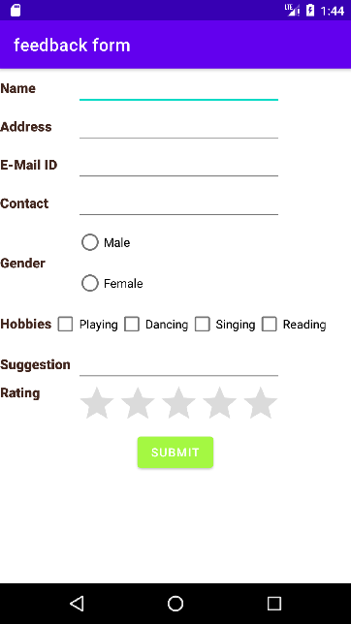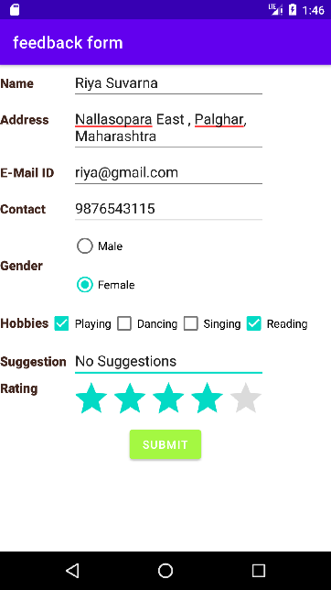

**Practical No.6**

**Aim:** Write an Android program to create login form using Intent. For successful login, display welcome page and attempts made. Disable the submit button after 3 wrong attempts. (Use image view to display image logo).

# Objective:

To understand working of login form.

# Code:

## MainActivity.java:-

package com.riya.loginpage; import

androidx.appcompat.app.AppCompatActivity; import android.content.Intent;

import android.view.View; import android.widget.Button; import android.widget.EditText; import android.widget.TextView; import android.os.Bundle;

public class MainActivity extends AppCompatActivity {

EditText user,pass; TextView counter; int count = 0; Button login; @Override

protected void onCreate(Bundle savedInstanceState) {

super.onCreate(savedInstanceState); setContentView(R.layout.*activity_main*);

counter=(TextView)findViewById(R.id.*txtcounter*)

;

user=(EditText)findViewById(R.id.*usr*); pass=(EditText)findViewById(R.id.*pass*); login=(Button)findViewById(R.id.*btn*); login.setOnClickListener(new

View.OnClickListener() { @Override

public void onClick(View view) { if(user.getText().toString().equals("admin")&&pas s.getText().toString().equals("admin"))

{

startActivity(new Intent(MainActivity.this,welcome.class));

}

else {

count++; counter.setText(String.*valueOf*(count));

if (count == 3)

{

login.setEnabled(false);

}}}});}}

## activity_main.xml:-

*<?*xml version="1.0" encoding="utf-8"*?>*

<RelativeLayout xmlns:android="<http://schemas.android.com/apk/re> s/android"

xmlns:app="<http://schemas.android.com/apk/res-> auto"

xmlns:tools="<http://schemas.android.com/tools>" android:layout_width="match_parent" android:layout_height="match_parent" tools:context=".MainActivity">

<TableRow android:id="@+id/r1"

android:layout_width="match_parent" android:layout_height="103dp" android:layout_centerHorizontal="true" android:layout_marginTop="50dp" android:padding="10dp">

<ImageView android:id="@+id/imageView" android:layout_width="wrap_content" android:layout_height="77dp" android:src="@drawable/images" />

<TextView android:id="@+id/textView" android:layout_width="wrap_content" android:layout_height="wrap_content" android:layout_gravity="center" android:text="Login Page" android:textAlignment="center" android:textColor="@color/teal_200" android:textSize="48sp" />

</TableRow>

<TableRow android:id="@+id/r2"

android:layout_width="wrap_content" android:layout_height="wrap_content" android:layout_below="@id/r1" android:layout_centerHorizontal="true" android:padding="10dp">

<TextView android:id="@+id/textView2" android:layout_width="wrap_content" android:layout_height="wrap_content" android:text="UserName" android:textSize="16sp" />

<EditText android:id="@+id/usr"

android:layout_width="wrap_content" android:layout_height="wrap_content" android:ems="10" android:inputType="textPersonName" />

</TableRow>

<TableRow android:id="@+id/r3"

android:layout_width="wrap_content" android:layout_height="wrap_content" android:layout_below="@id/r2" android:layout_centerHorizontal="true"

android:padding="10dp">

<TextView android:id="@+id/textView3" android:layout_width="wrap_content" android:layout_height="wrap_content" android:text="Password" android:textSize="16sp" />

<EditText android:id="@+id/pass"

android:layout_width="wrap_content" android:layout_height="wrap_content" android:ems="10"

android:inputType="textPersonName|textPassword "

/>

</TableRow>

<TableRow android:id="@+id/r4"

android:layout_width="wrap_content" android:layout_height="wrap_content" android:layout_below="@id/r3" android:layout_centerHorizontal="true" android:padding="10dp">

<Button

android:id="@+id/btn" android:layout_width="298dp" android:layout_height="wrap_content" android:background="#0D24A3" android:backgroundTint="#E91E63" android:text="Login" android:textSize="16sp" />

</TableRow>

<TableRow android:id="@+id/r5"

android:layout_width="wrap_content" android:layout_height="wrap_content" android:layout_below="@id/r4" android:layout_centerHorizontal="true" android:padding="10dp">

<TextView android:id="@+id/textView4" android:layout_width="wrap_content" android:layout_height="wrap_content" android:text="Invalid Attempt" android:textSize="16sp" />

<TextView android:id="@+id/txtcounter" android:layout_width="59dp" android:layout_height="wrap_content" android:textSize="16sp" />

</TableRow>

</RelativeLayout>

## welcome.java:-

package com.riya.loginpage; import android.os.Bundle; import android.widget.Toast;

public class welcome extends MainActivity { @Override

protected void onCreate(Bundle savedInstanceState) {

super.onCreate(savedInstanceState); setContentView(R.layout.*activity_welcome*); Toast.*makeText*(this, "This is New Activity",

Toast.*LENGTH_SHORT*).show();

}

}

## activity_welcome.xml:-

*<?*xml version="1.0" encoding="utf-8"*?>*

<RelativeLayout xmlns:android="<http://schemas.android.com/apk/re> s/android"

xmlns:tools="<http://schemas.android.com/tools>" android:layout_width="match_parent" android:layout_height="match_parent">

<TextView android:id="@+id/textView5" android:layout_width="wrap_content" android:layout_height="wrap_content"

android:text="Welcome to new activity" android:textSize="20sp" tools:layout_editor_absoluteX="125dp" tools:layout_editor_absoluteY="203dp" />

</RelativeLayout>

## AndroidManifest.xml:-

*<?*xml version="1.0" encoding="utf-8"*?>*

<manifest xmlns:android="<http://schemas.android.com/apk/re> s/android"

package="com.riya.loginpage" >

<application android:allowBackup="true" android:icon="@mipmap/ic_launcher" android:label="@string/app_name"

android:roundIcon="@mipmap/ic_launcher_round "

android:supportsRtl="true" android:theme="@style/Theme.LoginPage" >

<activity android:name=".MainActivity" android:exported="true" >

<intent-filter>

<action android:name="android.intent.action.MAIN" />

<category android:name="android.intent.category.LAUNCH ER" />

</intent-filter>

</activity>

<activity android:name=".welcome" />

</application>

</manifest>

# Output:

**Practical No.7**

**Aim:** Write an Android program to create Registration form with all the details displayed on next page on click of submit button using intent.

# Objective:

To understand working of Registration form.

# Code:

## MainActivity.java:-

package com.riya.registrationform; import

androidx.appcompat.app.AppCompatActivity; import android.content.Intent;

import android.os.Bundle; import android.view.View;

import android.widget.ArrayAdapter; import android.widget.Button; import android.widget.CheckBox; import android.widget.EditText; import android.widget.RadioButton; import android.widget.Spinner; public class MainActivity extends AppCompatActivity {

EditText name, addr, email, contact; CheckBox playing, singing, dancing, reading; Button submit;

RadioButton male, female; Spinner city;

String name1, addr1, email1, contact1, gender1,city1, hobbies1;

@Override

protected void onCreate(Bundle savedInstanceState) {

super.onCreate(savedInstanceState); setContentView(R.layout.*activity_main*); name=(EditText)findViewById(R.id.*name*); addr=(EditText) findViewById(R.id.*addr*); email=(EditText) findViewById(R.id.*email*); contact=(EditText)findViewById(R.id.*contact*); male=(RadioButton)

findViewById(R.id.*Male*); female=(RadioButton)

findViewById(R.id.*Female*); playing=(CheckBox)

findViewById(R.id.*Playing*); singing=(CheckBox)

findViewById(R.id.*Singing*); dancing=(CheckBox)

findViewById(R.id.*Dancing*);

submit=(Button) findViewById(R.id.*submit*); city=(Spinner) findViewById(R.id.*city*); Spinner spinner = (Spinner)

findViewById(R.id.*city*);

ArrayAdapter<CharSequence> adapter = ArrayAdapter.*createFromResource*(this,

R.array.*city*, android.R.layout.*simple_spinner_item*);

adapter.setDropDownViewResource(android.R.lay out.*simple_spinner_dropdown_item*);

spinner.setAdapter(adapter); submit.setOnClickListener(new

View.OnClickListener() { @Override

public void onClick(View view) { name1 = name.getText().toString(); email1 = email.getText().toString();

contact1 = contact.getText().toString(); addr1 = addr.getText().toString();

if (male.isChecked())

gender1 = male.getText().toString(); else if (female.isChecked())

gender1 = female.getText().toString();

playing.setOnClickListener((View.OnClickListene r) this);

singing.setOnClickListener((View.OnClickListener

) this);

dancing.setOnClickListener((View.OnClickListene r) this);

StringBuilder hobby = new StringBuilder();

if (playing.isChecked()) {

hobby.append(playing.getText().toString());

}

if (singing.isChecked()) {

hobby.append(singing.getText().toString());

}

if (dancing.isChecked()) {

hobby.append(dancing.getText().toString());

}

city1 = city.getSelectedItem().toString(); Intent it = new Intent(MainActivity.this,

data.class);

it.putExtra("name", name1); it.putExtra("email", email1); it.putExtra("address", addr1); it.putExtra("contact", contact1); it.putExtra("gender", gender1); it.putExtra("Hobbies", hobby.toString()); it.putExtra("city", city1); startActivity(it);

}

});

}

}

## activity_main.xml:-

<?xml version="1.0" encoding="utf-8"?>

<TableLayout xmlns:android="<http://schemas.android.com/apk/re> s/android"

xmlns:app="<http://schemas.android.com/apk/res-> auto"

xmlns:tools="<http://schemas.android.com/tools>" android:layout_width="match_parent" android:layout_height="match_parent" android:layout_centerHorizontal="true"

android:background="#FFFF2F" android:backgroundTint="#2FFFFF" android:orientation="vertical" android:paddingLeft="10dp" tools:context=".MainActivity">

<TableRow android:layout_width="match_parent" android:layout_height="match_parent" >

<TextView android:id="@+id/textView" android:layout_width="wrap_content" android:layout_height="wrap_content" android:text="Registration Form" />

</TableRow>

<TableRow android:layout_width="match_parent" android:layout_height="match_parent" >

<TextView android:id="@+id/textView1" android:layout_width="wrap_content" android:layout_height="wrap_content" android:text="Name" />

<EditText android:id="@+id/name"

android:layout_width="wrap_content" android:layout_height="wrap_content" android:ems="10" android:inputType="textPersonName" />

</TableRow>

<TableRow android:layout_width="match_parent" android:layout_height="match_parent" >

<TextView android:id="@+id/textView2" android:layout_width="wrap_content" android:layout_height="wrap_content" android:text="Email" />

<EditText android:id="@+id/email"

android:layout_width="wrap_content" android:layout_height="wrap_content" android:ems="10" android:inputType="textPersonName" />

</TableRow>

<TableRow android:layout_width="match_parent" android:layout_height="match_parent" >

<TextView

android:id="@+id/textView3" android:layout_width="wrap_content" android:layout_height="wrap_content" android:text="Address" />

<EditText android:id="@+id/addr"

android:layout_width="wrap_content" android:layout_height="wrap_content" android:ems="10" android:inputType="textPersonName" />

</TableRow>

<TableRow android:layout_width="match_parent" android:layout_height="match_parent" >

<TextView android:id="@+id/textView4" android:layout_width="wrap_content" android:layout_height="wrap_content" android:text="Contact" />

<EditText android:id="@+id/contact"

android:layout_width="wrap_content" android:layout_height="wrap_content" android:ems="10" android:inputType="textPersonName" />

</TableRow>

<TableRow android:layout_width="match_parent" android:layout_height="wrap_content" android:layout_marginBottom="10dp">

<TextView android:id="@+id/textView5" android:layout_width="wrap_content" android:layout_height="wrap_content" android:layout_gravity="center_vertical" android:text="Gender" android:textColor="@color/black" android:textSize="16sp" android:textStyle="bold" />

<RadioGroup android:id="@+id/gender" android:layout_width="wrap_content"

android:layout_height="wrap_content">

<RadioButton android:id="@+id/Male"

android:layout_width="wrap_content" android:layout_height="wrap_content" android:backgroundTint="#F8A9A9" android:text="Male" android:textColor="@color/black" />

<RadioButton android:id="@+id/Female" android:layout_width="wrap_content" android:layout_height="wrap_content" android:text="Female" android:textColor="@color/black" />

</RadioGroup>

</TableRow>

<TableRow android:layout_width="wrap_content"

android:layout_height="match_parent" android:layout_marginBottom="20dp">

<TextView android:id="@+id/textView6" android:layout_width="wrap_content" android:layout_height="wrap_content" android:text="Hobbies" android:textColor="@color/black" android:textSize="16sp" android:textStyle="bold" />

<TableRow android:layout_width="match_parent" android:layout_height="match_parent">

<CheckBox android:id="@+id/Playing"

android:layout_width="wrap_content" android:layout_height="wrap_content" android:text="Playing" android:textColor="@color/black" />

<CheckBox android:id="@+id/Dancing" android:layout_width="wrap_content" android:layout_height="wrap_content" android:text="Dancing" android:textColor="@color/black" />

<CheckBox android:id="@+id/Singing"

android:layout_width="wrap_content" android:layout_height="wrap_content" android:text="Sigining" android:textColor="@color/black" />

</TableRow>

</TableRow>

<TableRow android:layout_width="match_parent" android:layout_height="match_parent" android:layout_marginBottom="10dp">

<TextView android:id="@+id/textView7" android:layout_width="wrap_content" android:layout_height="wrap_content" android:text="City" android:textColor="@color/black" android:textSize="16sp" android:textStyle="bold" />

<Spinner android:id="@+id/city"

android:layout_width="match_parent" android:layout_height="wrap_content" />

</TableRow>

<TableRow android:layout_width="match_parent" android:layout_height="match_parent" android:gravity="center_horizontal">

<Button

android:id="@+id/submit" android:layout_width="wrap_content" android:layout_height="wrap_content" android:backgroundTint="#CE6ADF" android:text="Submit"

android:textColor="@color/black" />

</TableRow>

</TableLayout>

## data.java:-

package com.riya.registrationform; import

androidx.appcompat.app.AppCompatActivity; import android.os.Bundle;

import android.widget.TextView;

public class data extends AppCompatActivity {

TextView name,addr,email,contact,gender,city,hobbies;

@Override

protected void onCreate(Bundle savedInstanceState) {

super.onCreate(savedInstanceState); setContentView(R.layout.activity_data); name=(TextView)

findViewById(R.id.dname); email=(TextView) findViewById(R.id.demail);

addr=(TextView)findViewById(R.id.daddr); contact=(TextView)findViewById(R.id.dcontact);

gender=(TextView) findViewById(R.id.dgender); hobbies=(TextView)findViewById(R.id.dhobbies);

city=(TextView)findViewById(R.id.dcity); String name1 =

getIntent().getStringExtra("name");

String email1=getIntent().getStringExtra("email");

String addr1=getIntent().getStringExtra("address");

String contact1=getIntent().getStringExtra("contact");

String gender1=getIntent().getStringExtra("gender");

String city1=getIntent().getStringExtra("city");

name.setText("Name: "+name1); addr.setText("Address: "+addr1); contact.setText("Contact: "+contact1); email.setText("Email: "+email1); gender.setText("Gender: "+gender1); hobbies.setText("Hobbies:

"+getIntent().getStringExtra("Hobbies")); city.setText("City: "+city1); }}

## activity_data.xml:-

<?xml version="1.0" encoding="utf-8"?>

<RelativeLayout xmlns:android="<http://schemas.android.com/apk/re> s/android"

xmlns:app="<http://schemas.android.com/apk/res-> auto"

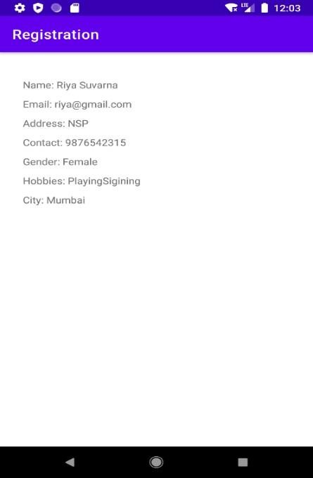xmlns:tools="<http://schemas.android.com/tools>" android:layout_width="match_parent" android:layout_height="match_parent" android:padding="30dp" tools:context=".data">

<TextView android:id="@+id/dname"

android:layout_width="wrap_content" android:layout_height="wrap_content" android:layout_marginTop="10dp" />

<TextView android:id="@+id/demail"

android:layout_width="wrap_content" android:layout_height="wrap_content" android:layout_below="@id/dname" android:layout_marginTop="10dp" />

<TextView android:id="@+id/daddr"

android:layout_width="wrap_content" android:layout_height="wrap_content" android:layout_below="@id/demail" android:layout_marginTop="10dp" />

<TextView android:id="@+id/dcontact"

android:layout_width="wrap_content" android:layout_height="wrap_content" android:layout_below="@id/daddr" android:layout_marginTop="10dp" />

<TextView android:id="@+id/dgender"

android:layout_width="wrap_content" android:layout_height="wrap_content" android:layout_below="@id/dcontact" android:layout_marginTop="10dp" />

<TextView android:id="@+id/dhobbies"

android:layout_width="wrap_content" android:layout_height="wrap_content" android:layout_below="@id/dgender" android:layout_marginTop="10dp" />

<TextView android:id="@+id/dcity"

android:layout_width="wrap_content" android:layout_height="wrap_content" android:layout_below="@id/dhobbies" android:layout_marginTop="10dp" />

</RelativeLayout>

## string.xml:-

<resources>

<string name="app_name">Registration</string>

<string-array name="city">

<item>Mumbai</item>

<item>Chennai</item>

<item>Delhi</item>

<item>Bangalore</item>

</string-array>

</resources>

# Output:

